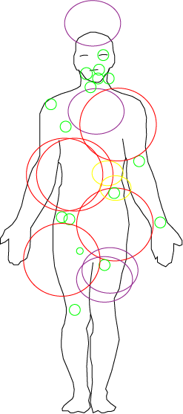

Gallbladder

Ureter

Kidney

Urinary Bladder

Prostate

Uterine Cervix/Corpus

Bones/joints

Lung/bronchus

Pancreas

Liver

Rectum

Colon

Small Intestine

Stomach

Breast

Esophagus

Larynx

Pharynx

Tongue

Thyroid

Mouth

Eye

Brain